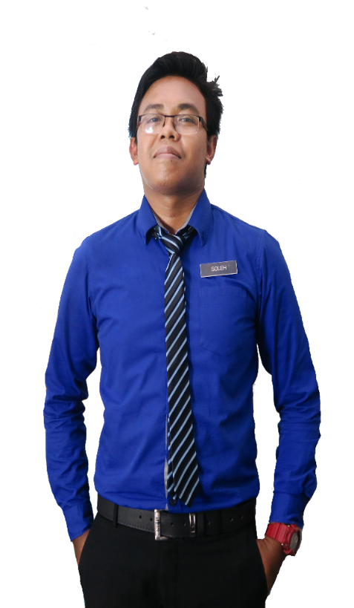

Prof. Dr. Mohamad Suffian Mohamad

Academic Advisor

Kolej Kediaman Tun Syed Zahiruddin

Universiti Teknologi Mara

[suffian_annuar@um.edu.my](mailto:suffian_annuar@um.edu.my)

+60160-2190 5697

**REFERENCE**

* Graphic Design Award 2015, Kuala Lumpur
* Anugerah Guru Cemerlang SMK Bandar Baru Sungai Buloh 2016
* Larian Hari Sukan Negara 2016, UiTM Kampus Puncak Alam
* Mount Kinabalu Hiking Expedition
* Volunteer for SUKMA 18, Pahang Darul Makmur
* Creative and Innovation Awards 2017

**ACHIEVEMENT**

**Leadership**

**Communication**

**Organization**

**Social Commitment**

**Creativity**

**PERSONAL SKILLS**

**Adobe Photoshop**

Bachelor of Education in Science (Hons) Chemistry

CGPA: 3.93

**UNIVERSITI TEKNOLOGI MARA PUNCAK ALAM**

2012-2014

**KOLEJ MATRIKULASI KEDAH, CHANGLUN**

Science Stream (Module II)

CGPA: 3.93

2012-2014

**SEKOLAH MEN KEB BANDAR BARU SG BULOH**

Sijil Pelajaran Malaysia

2012-2014

Master of Education in Science

CGPA: 3.93

2012-2014

**UNIVERSITI TEKNOLOGI MARA SHAH ALAM**

**EDUCATION**

Implements curriculum objectives and goals using effective teaching techniques and materials. Develops, in a cooperative manner with the principal and curriculum facilitators, a plan for the improvement and enrichment of instruction.

2012-2014

**SEKOLAH MEN KEB KUALA TEKAL**

Teacher

**TEACHER & GRAPHIC DESIGNER**

**MUHD SOLEH**

Implements curriculum objectives and goals using effective teaching techniques and materials. Develops, in a cooperative manner with the principal and curriculum facilitators, a plan for the improvement and enrichment of instruction.

Teacher

**SEKOLAH MEN KEB BANDAR BARU SG BULOH**

2012-2014

2012-2014

Teach at undergraduate and graduate level in areas allocated by the Head of Department and reviewed from time to time by the Head of Department. Carry out research and produce publications, or other research outputs, in line with personal objectives agreed in the Staff review process.

**UNIVERSITI TEKNOLOGI MARA SHAH ALAM**

Lecturer

resumecreative@yahoo.com

Creative Resume, 74000 Bandar Puncak Alam, Selangor

**PROFESSIONAL SKILLS**

**LANGUAGE**

**JOB EXPERIENCE**

**EMAIL**

013-2805916

**MOBILE**

**ADDRESS**

**Mandarin**

**Malay**

**English**

**Microsoft Word**

**Microsoft Excel**

**Microsoft PowerPoint**